

38 Chapter Two 1he JO Cort Co11cept1

Core Concept #6

PRIVILEGE

In terms of a definition, privilege can best b described as acce.ss co resources based solely on the person's status as a member of che advmztaged group. Privilege is a concept rh.it
many people in 11dva11tngedgroups havedifficulty undemanding
t or accepting. A common reaction is to 61:come defensive and I feel they are being categorized unfairly. lc's as though they are ;1
being accused of cheating when they haven't done anything
wrong. Privilege is given, not earned. It is distributed based on !
what group a person belongs to, rather than what they have or ·1
have not accomplished. One of my favorite quotes is by Barry i
Switzer who says, "Some people are born on chird base and go through \ife thinking they've hit a triple." People in adva,,ragtd groups need to be reminded that they have been given a head
start, chat their journey begins on third base without even taking a swing. Whecher or not they asked for chis head start is irrelevant • they have it. \'(fhac matters most is what they do with their privilege.
lee me give _{)'OU} a coup\e of examples. The first example speaks co white privilege. Mally white people often say char rhey have earned everything they achieved in their lives, without





• • • • • • :c
..
r,
,:.:,
r.
:::
.C,..,...
.tr.. .
.0,
-
r.
,:.:,
c...
.-...
r.
;;.·
r.
,:.:, .,

"'

....
-
,._
,-,
::.:
;;.
r..
-
-::.;
,..

:r.
VI
.::.;.
.:...:
- -r-:.:.
.,
;:;
r<:.
:::
8
0
;-,
c


:;:-;-

.
...0.,-.
-•
gr,

...
...
::.;
::!.
-
0



,;.=_:·

-
-:::·
i



7 r..



::.:


"·
r.
'J r:
.-..
<r.
...
-
..
,.
..,
r;

(,)
U1
Cl
C:
3
cr

-i
;::;
5"
(0
(/)

'::J
:c:i,i

a.

-
r .
--
...
.,-
.2,

...._{--:}

-,...
.,-
....


.c.,


r.

...
c...
C
fr,'
r,
g
.-...
CaD.
"'O

'O
15"
CJ)
Ill '<


40 Chapter Two The JO Core Concepts

Another example of privilege is heterosexual privilege and the institution of marriage. With the exception of the states of Massachusetts and California, only heterosexual couples can be legally married. They don't have co "do" anything but be heterosexual, and they aucomatically gain the privilege of marriage, with all of che legal rights and benefits associated with that institution. Married heterosexual couples are automatically given many legal rights such as spousal health insurance, recipient of a spouse's pension plan, ability to visit a spouse in the hospital when visitarion is limited to only "family" members, tax benefits, ability co adopt children without regard co sexual orientation, discounts on memberships co fitness dubs ere. The list goes on and on.
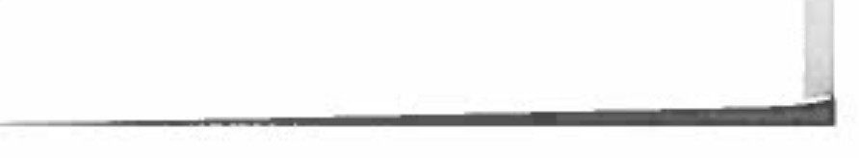
Not only are there legal privileges and benefits, there is the issue of social acceptance as well. Society builds entire industries to support and encourage heterosexual marriages. From wedding planning, shower registries, honeymoon destinations, co the assurance that you can introduce a loved one to family members without fear of rejection, are a few of the distinctions heterosexuals enjoy. Simply purchasing a greeting card for a loved one becomes a challenging task for gay and lesbian couples because rhe wording and pictures on the card are composed for heterosexuals.

"Consistency of behavior can ultimately be unfair. "
MAURA J CULLEN

